Product Inventory Management System
1. Introduction
A Product Inventory Management System is a software application used to track, manage, and organize products in a store or company. It helps businesses monitor stock levels, sales, purchases, and product details efficiently.
Inventory management ensures that the right products are available at the right time without overstocking or running out of items.

Team ID : SWTID-2026-6547
Team Size : 4
Team Leader : AMRIN BEGUM L
Team member : BHARATHI K
Team member : DHARSHINI PRIYA K
Team member : DHARSHINI T

2. Objectives
- To maintain accurate records of products.
- To track the quantity of items available in stock.
- To manage product purchases and sales.
- To reduce manual work and human errors.
- To improve business efficiency and decision making.
3. Features of Inventory Management System
- Product Management – Add, update, and delete product details.
- Stock Tracking – Monitor the quantity of each product in stock.
- Sales Management – Record product sales and update stock automatically.
- Purchase Management – Manage purchases from suppliers.
- Report Generation – Generate reports for stock, sales, and purchases.
4. Components of Inventory System
4.1 Product
Stores product information such as:
- Product ID
- Product Name
- Category
- Price
- Quantity
4.2 Supplier
Information about the suppliers who provide products.
4.3 Stock
Shows the available quantity of each product in the inventory.
4.4 Customer
Stores customer information when products are sold.
5. Advantages
- Saves time and effort.
- Reduces human errors.
- Helps in better stock control.
- Improves business productivity.
- Provides accurate reports.
6. Disadvantages
- Initial setup cost.
- Requires technical knowledge.
- System failure may affect operations.
7. Applications
- Inventory management systems are used in:
- Retail stores
- Supermarkets
- Warehouses
- Manufacturing industries
- E-commerce companies


Inventory product management
Ideation Phase
Brainstorm & Idea Prioritization Template
Brainstorming is used to generate creative ideas and identify the most suitable solution for a
real-world problem. During the ideation phase, team members collaborated to discuss common
issues faced in managing product inventories and explored multiple web-based solutions using
the MERN stack. Ideas were evaluated based on feasibility, scalability, security, and learning
outcomes.
Step-1: Team Gathering, Collaboration and
Select the Problem Statement
The team conducted a discussion session to identify common problems that could be solved
using full-stack development. Several ideas were proposed such as:
● E-commerce product tracker
● Expense manager
● Task management system
● Cryptocurrency dashboard
● Inventory management system
After evaluating complexity, real-world usefulness, and alignment with MERN stack learning
objectives, the team finalized the following problem statement:
Problem Statement:
Small businesses and individual users lack a simple, secure, and centralized system to
Manage | their | product | inventory. Many existing solutions are complex or require paid
subscriptions. Therefore, the team decided to build a JWT-based Product Inventory
Management System that allows users to securely manage their own products.


Step-2: Brainstorm, Idea Listing and
Grouping
During brainstorming, all team members contributed ideas without restrictions. The ideas were
then grouped into categories:
Authentication & Security Ideas
● JWT-based login system
● User-specific product access
● Secure password hashing
● Role-based access (future scope)
Core Inventory Features
● Add product
● Update product details
● Delete product
● View all products
● Search products by name
User Experience Ideas
● Simple dashboard UI
● Responsive design
● Clean product cards layout
● Fast loading using React
Technical Ideas
● MERN stack architecture
● REST API development
● MongoDB database design
● Middleware for route protection
After grouping, the team focused on ideas that were realistic within the project timeline.


Step-3: Idea Prioritization
The team prioritized ideas based on:
● Feasibility within deadline
● Learning value
● Practical real-world use
● Technical complexity
High Priority (Implemented Features)
● JWT Authentication (Register/Login)
● Private product CRUD operations
● MongoDB database integration
● Secure API routes
● Search functionality
Medium Priority (Enhancements)
● Product filtering
● Improved UI components
● Error handling improvements
Low Priority / Future Scope
● Role-based admin system
● Analytics dashboard
● Notifications for low stock
● Deployment and cloud hosting
Final Decision:
The team finalized the Product Inventory Management System as it provides strong learning
opportunities in authentication, backend API design, and frontend integration using MERN stack
technologies

Project Design Phase-II
Solution Requirements (Functional & Non-functional)
Date

Team ID

Project Name

Maximum Marks
4 Marks

Functional Requirements:
Following are the functional requirements of the proposed solution.
FR No.
Functional Requirement (Epic)
Sub Requirement (Story / Sub-Task)
FR-1
User Authentication &
Authorization
User can register with email and password

User can log in securely using JWT

Only authenticated users can access dashboard
FR-2
Product Management
(CRUD)
Add new product with name, price, quantity and
Description

View all products in dashboard

Non-functional Requirements:
Following are the non-functional requirements of the proposed solution.
NFR
No.
Non-Functional Requirement
Description
NFR-1
Usability
The application should have a simple and
Intuitive user interface so users can manage
Products easily.
NFR-2
Security
JWT authentication must be used. Passwords
Should be hashed and unauthorized access must
Be prevented.

NFR-3
Reliability
The system should provide consistent
Performance with minimal server errors or
Downtime.
NFR-4
Performance
Product data should load quickly and API responses
Should be returned within 2 seconds.
NFR-5
Availability
The system should remain accessible to users with
Minimal downtime during operation.
NFR-6
Scalability
The architecture should support increasing numbers of users and products without performance issues.
Future features should be easy to integrate.


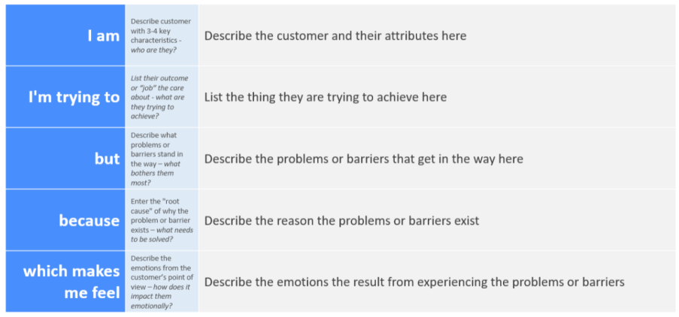
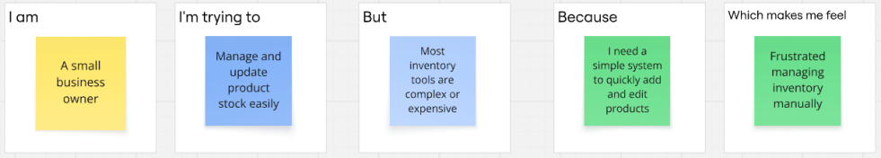
Product Inventory Management System
Ideation Phase

Customer Problem Statement Template:
The Customer Problem Statement helps identify the challenges faced by users while managing
product inventories. Understanding the user's perspective allows the team to design a system
that is secure, simple, and efficient. By analyzing user needs, the project focuses on creating a
Customer Problem Statement Template:
The Customer Problem Statement helps identify the challenges faced by users while managing
product inventories. Understanding the user's perspective allows the team to design a system
that is secure, simple, and efficient. By analyzing user needs, the project focuses on creating a
practical inventory management solution using the MERN stack.

Problem  Statement |   I am  (Customer) | I’m trying  to | But | Because | Which makes  me feel
PS-1 | A small  business  owner | Manage  product  stock  efficiently | Existing tools  are  complicated  or expensive | I need a simple system to add  and update  products  quickly | Frustrated  managing  inventory  manually
PS-2 | A freelancer  selling  products  online | Track  available  items and  pricing | Data gets lost  without a  centralized  platform | I want a secure  dashboard  where only I  can manage my  products | Stressed about  losing  important  product data
PS-3 | A shop  manager | Update  stock  quantity  regularly | There is no  easy real-time CRUD system | I need a fast  and responsive web app to  update  inventory  anytime | Anxious when  stock  information is  outdated
PS-4 | A new  entrepreneur | Organize  products in one place | Many  inventory  apps require  complex  setup | I want a  lightweight and user-friendly  inventory  solution | Overwhelmed  by complicated  software

Product Inventory Management System
Ideation Phase
Empathize & Discover
Empathy Map Canvas:
An empathy map is a simple, easy-to-digest visual that captures knowledge about a user’s behaviours and attitudes.

It is a useful tool to helps teams better understand their users.
Creating an effective solution requires understanding the true problem and the person who is experiencing it. The exercise of creating the map helps participants consider things from the user’s perspective along with his or her goals and challenges.
Example:


Reference: https://www.mural.co/templates/empathy-map-canvas

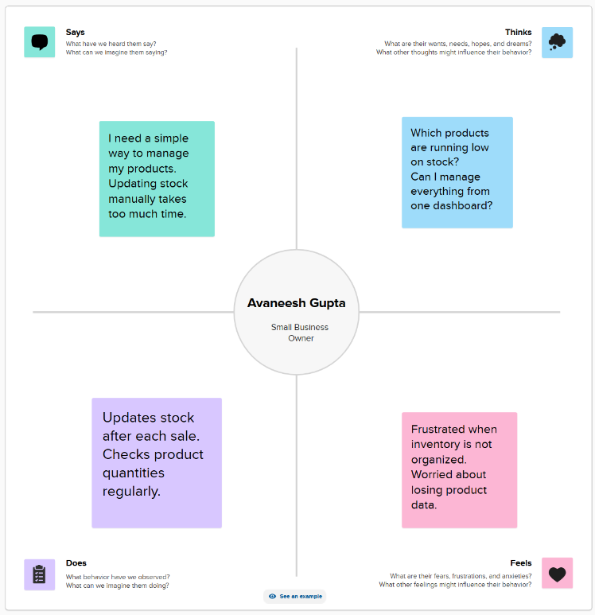

Project Design Phase-II
Data Flow Diagram & User Stories

Date
Team ID
Project Name
Maximum Marks | 4 Marks

Data Flow Diagrams:
A Data Flow Diagram (DFD) is a traditional visual representation of the information flows within a system. A neat and clear DFD can depict the right amount of the system requirement graphically. It shows how data enters and leaves the system, what changes the information, and where data is stored.
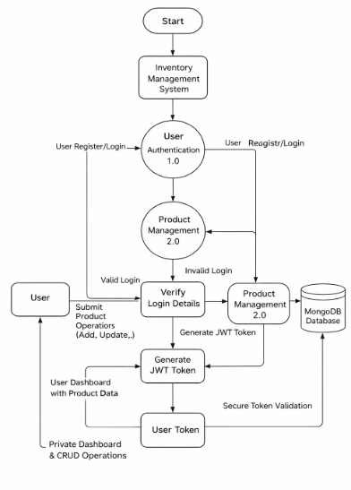
User Stories
Use the below template to list all the user stories for the product.
User Type | User Story Number | User Story / Task | Acceptance Criteria | Priority | Release
Customer (Web User) | USN-1 | As a user, I can register and log in securely using JWT authentication | User can create account and receive token after login | High | Sprint-1
Customer (Web User) | USN-2 | As a user, I can add new products to my inventory | Product is saved and visible only to logged-in user | High | Sprint-1
Customer (Web User) | USN-3 | As a user, I can view all my products in a dashboard | Products load successfully with valid token | High | Sprint-1
Customer (Web User) | USN-4 | As a user, I can update product details like price and quantity | Changes are saved and reflected instantly | Medium | Sprint-2
Customer (Web User) | USN-5 | As a user, I can delete products from my inventory | Product disappears from dashboard after deletion | Medium | Sprint-2
Customer (Web User) | USN-6 | As a user, I can search products by name | Filtered results appear based on keyword | Low | Sprint-2

Project Design Phase-II
Solution Requirements (Functional & Non-functional)

Functional Requirements:
Following are the functional requirements of the proposed solution.
FR No. | Functional Requirement (Epic) | Sub Requirement (Story / Sub-Task)
FR-1 | User Authentication & Authorization | User can register with email and password
 |  | User can log in securely using JWT
 |  | Only authenticated users can access dashboard
FR-2 | Product Management (CRUD) | Add new product with name, price, quantity and description
 |  | View all products in dashboard

Non-functional Requirements:
Following are the non-functional requirements of the proposed solution.
NFR No. | Non-Functional Requirement | Description
NFR-1 | Usability | The application should have a simple and intuitive user interface so users can manage products easily.
NFR-2 | Security | JWT authentication must be used. Passwords should be hashed and unauthorized access must be prevented.
NFR-3 | Reliability | The system should provide consistent performance with minimal server errors or downtime.
NFR-4 | Performance | Product data should load quickly and API responses should be returned within 2 seconds.
NFR-5 | Availability | The system should remain accessible to users with minimal downtime during operation.
NFR-6 | Scalability | The architecture should support increasing numbers of users and products without performance issues. Future features should be easy to integrate.

Project Design Phase-II
Technology Stack (Architecture & Stack)

Technical Architecture:
The system follows a MERN Stack Architecture where the React frontend communicates with a Node.js + Express backend through REST APIs. Authentication is handled using JWT tokens, and all user and product data is stored in MongoDB.
The Deliverable shall include the architectural diagram as below and the information as per the table1 & table 2
Table-1 : Components & Technologies:
S.No | Component | Description | Technology
1 | Application Logic-1 | User authentication, JWT token generation and validation | Node.js, Express.js, bcryptjs, jsonwebtoken
2 | Application Logic-2 | Product CRUD operations and search functionality | Node.js, Express.js REST API
3 | Database | Store user accounts and product inventory data securely | MongoDB Atlas, Mongoose
4 | API Communication | Handles secure data transfer between frontend and backend | REST API, Axios, HTTPS

Table-2: Application Characteristics:
S.No | Characteristics | Description | Technology
1 | Open-Source Frameworks | Backend frameworks used in the system | Node.js, Express.js, Mongoose
2 | Scalable Architecture | Modular MVC architecture supporting future features | REST API Architecture, JWT Middleware
3 | Security | Secure authentication and protected routes | JWT Authentication, bcrypt Password Hashing
4 | Performance Optimization | Fast loading UI and efficient database queries | Vite, MongoDB Indexing
5 | Responsive Design | Supports multiple devices and screen sizes | Tailwind CSS, Responsive Layout

Project Planning Phase
Project Planning Template (Product Backlog, Sprint Planning, Stories, Story points)

Product Backlog, Sprint Schedule, and Estimation (4 Marks)

Sprint | Functional Requirement (Epic) | User Story Number | User Story / Task | Story Points | Priority | Team Members
Sprint-1 | Backend Setup | USN-1 | Initialize Node.js project and configure Express server | 6 | High | Avaneesh
Sprint-1 | Database Setup | USN-2 | Connect MongoDB Atlas and create database structure | 6 | High | Avaneesh
Sprint-1 | User Model | USN-3 | Create User schema with password hashing | 8 | High | Avaneesh
Sprint-2 | JWT Authentication | USN-4 | Implement register and login APIs with JWT token | 8 | High | Avaneesh
Sprint-2 | Auth Middleware | USN-5 | Create JWT verification middleware for protected routes | 6 | High | Avaneesh
Sprint-2 | Product Model | USN-6 | Design Product schema linked with userId | 6 | High | Avaneesh
Sprint-3 | Product CRUD APIs | USN-7 | Implement Add, Get, Update, Delete product APIs | 10 | High | Avaneesh
Sprint-3 | Search API | USN-8 | Implement product search/filter endpoint | 6 | Medium | Avaneesh
Sprint-3 | Authorization Logic | USN-9 | Ensure users can access only their own products | 6 | High | Avaneesh
Sprint-4 | Error Handling | USN-10 | Implement centralized error handling middleware | 6 | Medium | Avaneesh
Sprint-4 | API Testing | USN-11 | Test APIs using Postman and validate responses | 5 | Medium | Avaneesh
Sprint-4 | Backend Optimization | USN-12 | Improve API performance and validation checks | 5 | Medium | Avaneesh

Project Tracker, Velocity & Burndown Chart: (4 Marks)
Sprint | Total Story Points | Duration | Sprint Start Date | Sprint End Date (Planned) | Story Points Completed | Sprint Release Date (Actual)
Sprint-1 | 20 | 5 Days | 17 Feb 2026 | 21 Feb 2026 | 20 | 21 Feb 2026
Sprint-2 | 20 | 5 Days | 22 Feb 2026 | 26 Feb 2026 | 20 | 26 Feb 2026
Sprint-3 | 22 | 5 Days | 27 Feb 2026 | 3 Mar 2026 | 22 | 3 Mar 2026
Sprint-4 | 16 | 4 Days | 4 Mar 2026 | 8 Mar 2026 | 16 | 8 Mar 2026

Project Design Phase
Problem – Solution Fit Template
Problem – Solution Fit Overview:
The Problem–Solution Fit ensures that the backend system is designed to solve real-world challenges related to product inventory management. It validates that the proposed API architecture, authentication system, and database design effectively address user needs for secure and efficient inventory handling.
Purpose:
- Address the lack of a secure and structured backend system for managing product inventories.
- Provide reliable REST APIs for product CRUD operations with private user-based access.
- Implement JWT-based authentication to ensure secure communication between clients and server.
- Enable efficient data storage and retrieval using MongoDB with proper authorization checks.
- Improve backend scalability and maintainability using modular Node.js and Express architecture.
Problem Statement:
Many small businesses and individual sellers rely on manual systems or unsecured applications to manage product inventories. Existing solutions often lack proper authentication, structured APIs, or user-specific data protection, which can lead to data inconsistency and unauthorized access. Without a well-designed backend architecture, managing inventory securely and efficiently becomes difficult.
Solution
A Node.js and Express.js based Backend Application designed to provide secure and scalable APIs for product inventory management.
- JWT authentication ensures that only authorized users can access protected routes.
- RESTful APIs allow users to create, read, update, and delete products efficiently.
- MongoDB database integration stores user and product data securely with userId-based authorization.
- Middleware-based architecture handles token verification, request validation, and error handling.
- Modular backend structure improves scalability, maintainability, and future feature expansion

- Project Design Phase
- Proposed Solution Template
- Proposed Solution Template:
- Project team shall fill the following information in the proposed solution template.
S.No. | Parameter | Description
1 | Problem Statement (Problem to be solved) | Many small businesses and individual users struggle to manage product inventory securely due to lack of structured backend systems. Existing solutions either lack proper authentication, have complex setups, or do not provide private user-based data management, leading to inefficient inventory handling.
2 | Idea / Solution Description | Develop a Node.js and Express.js based backend system that provides secure REST APIs for product inventory management. The solution uses JWT authentication, MongoDB database integration, and middleware-based authorization to ensure users can securely perform CRUD operations on their own products.
3 | Novelty / Uniqueness | The backend focuses on user-specific inventory management with JWT-protected APIs, modular MVC architecture, and scalable REST endpoints. It ensures data privacy by linking each product with a unique userId and implementing secure token verification for all protected routes.
4 | Social Impact / Customer Satisfaction | The system helps small businesses and individual sellers manage inventory efficiently without expensive software. Secure backend APIs promote data privacy, reliability, and scalability, improving overall user trust and satisfaction.

Project Design Phase
Solution Architecture

Solution Architecture:
The solution architecture for the Product Inventory Management System focuses on building a secure, scalable, and maintainable backend using Node.js, Express.js, and MongoDB. The backend provides RESTful APIs for authentication and product management while ensuring data privacy through JWT-based authorization.
Goals of the Solution Architecture:
Identify the Best Tech Solution:
- Use Node.js, Express.js, MongoDB, and JWT authentication to build a secure and efficient backend API for product inventory management.
Define Structure & Characteristics:
- Follow a modular MVC architecture to ensure scalability, maintainability, and clear separation of authentication and product management logic.
Outline Features & Development Phases:
- Plan development in phases including backend setup, authentication APIs, product CRUD operations, and testing for stable delivery.
Establish Specifications for Development & Delivery:
- Define REST API standards, token-based authorization, and structured middleware to maintain consistent and secure data flow.
- Optimize database queries and asynchronous API handling to provide fast response times and reliable backend performance.

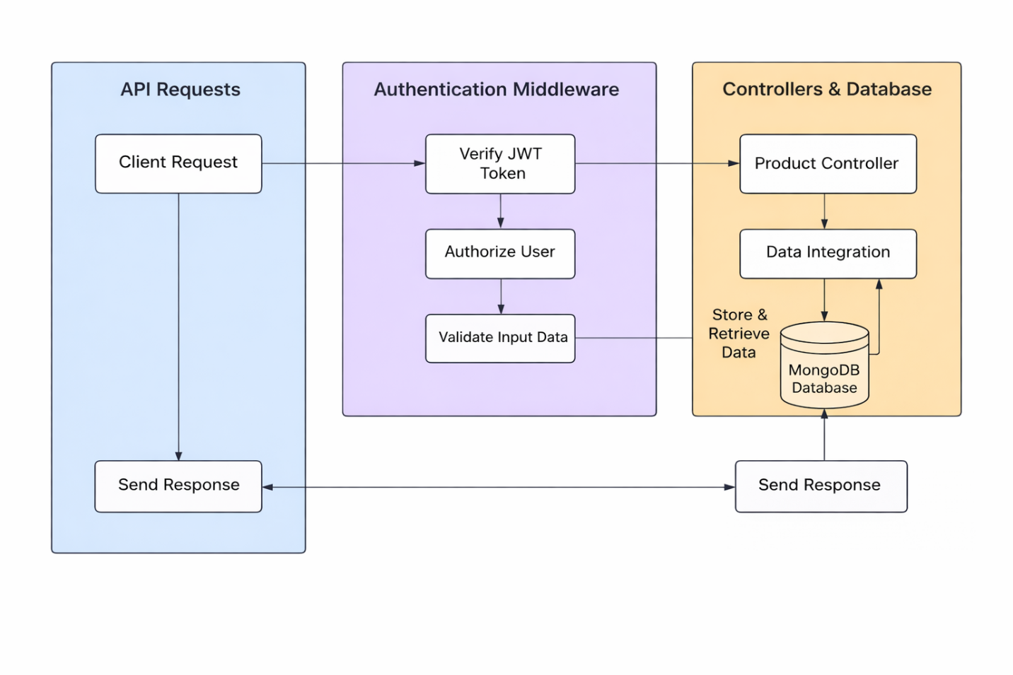

User Acceptance Testing (UAT) Template

Project Overview
Project Name: Product Inventory Management System (Backend)
Project Description: A Node.js and Express.js based backend application that provides secure REST APIs for managing product inventory using JWT authentication. The system allows users to register, log in, and perform CRUD operations on their own products while ensuring data privacy through token-based authorization.
Project Version: v1.0
Testing Period: March 5, 2026 – March 10, 2026

Testing Scope
Features and Functionalities to be Tested
- User Registration API
- User Login API with JWT Token
- Authentication Middleware (Protected Routes)
- Product CRUD APIs (Add, View, Update, Delete)
- Search/Filter API
- Database Integration with MongoDB
- Error Handling & API Response Validation
User Stories or Requirements to be Tested
- User can register and receive valid API response
- User can log in and receive JWT token
- Only authenticated users can access product routes
- Users can manage only their own products
- API returns proper error messages for invalid requests

Test Cases
Test Case ID | Test Scenario | Test Steps | Expected Result | Actual Result | Pass/Fail
TC-001 | Register User API | 1. Send POST request to /register 2. Provide valid data | User created successfully with response message | [Actual Result] | [Pass/Fail]
TC-002 | Login API | 1. Send POST request to /login 2. Provide credentials | JWT token returned in response | [Actual Result] | [Pass/Fail]
TC-003 | Protected Route Access | 1. Call /products without token | Access denied with 401 error | [Actual Result] | [Pass/Fail]
TC-004 | Create Product API | 1. Send POST request with token | Product saved in database | [Actual Result] | [Pass/Fail]
TC-005 | Update Product API | 1. Send PUT request with token | Product updated successfully | [Actual Result] | [Pass/Fail]
TC-006 | Delete Product API | 1. Send DELETE request with token | Product removed from database | [Actual Result] | [Pass/Fail]

Bug Tracking
Bug ID | Bug Description | Steps to Reproduce | Severity | Status | Additional Feedback
BG-001 | Unauthorized access allowed without token | Call protected route without JWT | High | Open | Fix middleware validation
BG-002 | Product update fails with invalid ID | Send incorrect product ID | Medium | In Progress | Add validation check
BG-003 | API response delay during large data fetch | Request multiple products | Low | Open | Optimize database query

Sign-off
Tester Name: [Enter Name]
Date: [Enter Date of Completion]
Signature: [Enter Signature]

Notes
- Ensure testing covers both positive & negative cases
- Bug tracking should include severity levels & reproduction steps
- Final sign-off required before deployment

8. Conclusion
A Product Inventory Management System is essential for businesses to manage their stock effectively. It helps in tracking products, reducing errors, and improving overall efficiency. Implementing such a system can greatly enhance business operations and customer satisfaction.

